<https://medium.com/google-cloud/full-relational-diagram-for-ethereum-public-data-on-google-bigquery-2825fdf0fb0b>

# Full relational diagram for Ethereum public data on Google BigQuery

[[](https://medium.com/@rifkiamil?source=post_page-----2825fdf0fb0b--------------------------------)](https://medium.com/@rifkiamil?source=post_page-----2825fdf0fb0b--------------------------------)

[[Google Cloud - Community](https://medium.com/google-cloud?source=post_page-----2825fdf0fb0b--------------------------------)](https://medium.com/google-cloud?source=post_page-----2825fdf0fb0b--------------------------------)

[Rif Kiamil](https://medium.com/@rifkiamil?source=post_page-----2825fdf0fb0b--------------------------------)

·

[Follow](https://medium.com/m/signin?actionUrl=https%3A%2F%2Fmedium.com%2F_%2Fsubscribe%2Fuser%2F37811c1406d9&operation=register&redirect=https%3A%2F%2Fmedium.com%2Fgoogle-cloud%2Ffull-relational-diagram-for-ethereum-public-data-on-google-bigquery-2825fdf0fb0b&user=Rif+Kiamil&userId=37811c1406d9&source=post_page-37811c1406d9----2825fdf0fb0b---------------------post_header-----------)

Published in

[Google Cloud - Community](https://medium.com/google-cloud?source=post_page-----2825fdf0fb0b--------------------------------)

·

4 min read

·

Feb 23, 2021

312

1

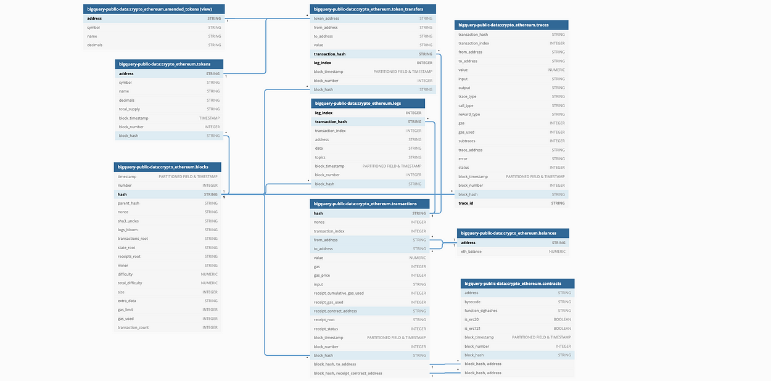

<https://dbdiagram.io/d/602e721380d742080a3b1265>

Find a full relational diagram for Ethereum data coming from an amazing opensource project [Blockchain-ETL](https://github.com/blockchain-etl).

# Usage Examples

## 1. crypto\_ethereum.transactions

The transactions table has the normal Ethereum transactions, and if you need to find the internal transactions, you need to query the trace table.

*Internal transactions are not actually considered transactions, as they are not included directly in the blockchain. Instead can only be seen as a byproduct of having tracing on.*

## 2. crypto\_ethereum.contracts

Note — Don’t have any unique key on contracts table

**Contracts & Transactions**

contracts.address can be fond transactions.to\_address or transactions.receipt\_contract\_address.

**transactions.to\_address** - Address of the receiver. null when its a contract creation transaction.**transactions.receipt\_contract\_address** - The contract address created, if the transaction was a contract creation, otherwise null.

**Joining Contracts & Transactions**

You must use a composite foreign key when joining contracts & transactions.

"crypto\_ethereum.transactions".("block\_hash", "to\_address") < "bigquery-public-data:crypto\_ethereum.contracts".("block\_hash", "address")OR"bigquery-public-data:crypto\_ethereum.transactions".("block\_hash", "receipt\_contract\_address") < "bigquery-public-data:crypto\_ethereum.contracts".("block\_hash", "address")

**Contracts & Trace**

Trace.from\_address and Trace.to\_address can both have contract.address

## 3. crypto\_ethereum.traces

Learn more about tracing in Ethereum <https://openethereum.github.io/JSONRPC-trace-module>, the JSONRPC-trace-module is used to populates table crypto\_ethereum.traces.

*Internal transactions are not actually considered transactions, as they are not included directly in the blockchain. Instead can only be seen as a byproduct of having tracing on*

[**Etherscan.io**](https://etherscan.io/tx/0x09b8fc0deb96a27ddd9f20d8ca5d76931dc2fa5be97191ab04ce12239b0d6525#internal)**Internal Transactions Simplified and Advanced**

If you use Etherscan to look up internal transactions, be aware of a Toggle between Simple and Advanced view

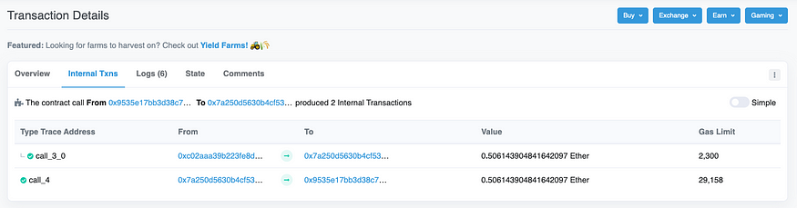

[Toggle Off](https://etherscan.io/tx/0x09b8fc0deb96a27ddd9f20d8ca5d76931dc2fa5be97191ab04ce12239b0d6525#internal)

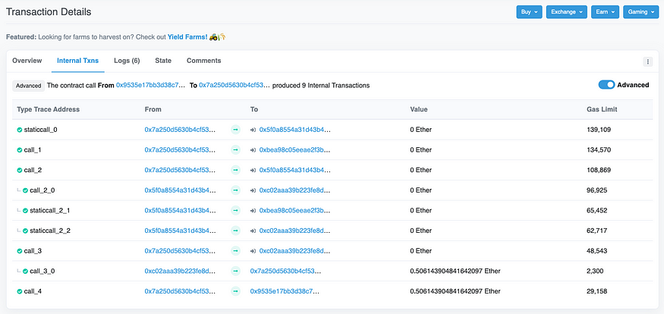

Toggle On

**Internal Transactions Simple View**

How to query the trace table for internal transactions [(default/simple view from Etherscan.io )](https://etherscan.io/tx/0x09b8fc0deb96a27ddd9f20d8ca5d76931dc2fa5be97191ab04ce12239b0d6525#internal). The total rows returned will match the Etherscan information screen regarding blocks.

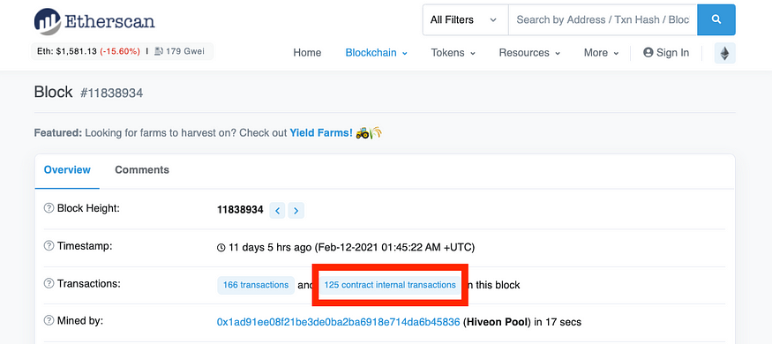

125 internal transactions ( actually, there are more, these are ones that have a value > 0 )

**Internal Transactions Advanced View**

How to query the trace table for internal transactions ([advanced view from Etherscan.io](https://etherscan.io/tx/0x09b8fc0deb96a27ddd9f20d8ca5d76931dc2fa5be97191ab04ce12239b0d6525/advanced#internal))

## 3. crypto\_ethereum.amended\_tokens

Token amended with [data from CSV](https://github.com/blockchain-etl/ethereum-etl-airflow/blob/master/dags/resources/stages/seed/data/token_amendments.csv).

Deduplicate first since the tokens table might have duplicate entries due to CREATE2 <https://medium.com/@jason.carver/defend-against-wild-magic-in-the-next-ethereum-upgrade-b008247839d2>

##Query for View amended\_tokensWITH tokens AS (  
 -- Deduplicate first since the tokens table might have duplicate entries due to CREATE2 <https://medium.com/@jason.carver/defend-against-wild-magic-in-the-next-ethereum-upgrade-b008247839d2>  
 SELECT   
 address,  
 ANY\_VALUE(symbol) AS symbol,  
 ANY\_VALUE(name) AS name,  
 ANY\_VALUE(decimals) AS decimals,  
 FROM `bigquery-public-data.crypto\_ethereum.tokens`  
 GROUP BY address  
)  
SELECT   
 address,  
 COALESCE(am.symbol, tokens.symbol) AS symbol,  
 COALESCE(am.name, tokens.name) AS name,  
 COALESCE(am.decimals, tokens.decimals) AS decimals,  
FROM  
 `blockchain-etl-internal.common.token\_amendments` AS am  
FULL OUTER JOIN  
 tokens  
USING(address)

## 4. crypto\_ethereum.tokens

List of tokens

## 5. crypto\_ethereum.token\_transfers

The most popular type of transaction on the Ethereum blockchain invokes a contract of type ERC20 to perform a transfer operation, moving some number of tokens from one 20-byte address to another 20-byte address. This table contains the subset of those transactions and has further processed and denormalized the data to make it easier to consume for analysis of token transfer events.

## 6. crypto\_ethereum.logs

Similar to the token\_transfers table, the logs table contains data for smart contract events. However, it contains all log data, not only ERC20 token transfers. This table is generally useful for reporting on any logged event type on the Ethereum blockchain.

## 7. crypto\_ethereum.balances

This table contains Ether balances of all addresses, updated daily.

Run-on [BigQuery](https://console.cloud.google.com/bigquery?sq=819168234572:c1cd90fa232b42a6ba31efce1f6ff67e" \t "_blank).

# Partitioned Fields

You can see “Partitioned Field” if the table does have a partition setup in the diagram.

When working with the following tables

* crypto\_ethereum.contracts
* crypto\_ethereum.logs
* crypto\_ethereum.token\_transfers
* crypto\_ethereum.traces
* crypto\_ethereum.transactions

Try to use a partitioned field. This will speed up your queries and reduce your costs.

WHERE transactions.block\_timestamp = '2021-01-21'  
WHERE blocks.timestamp = '2010-12-05'

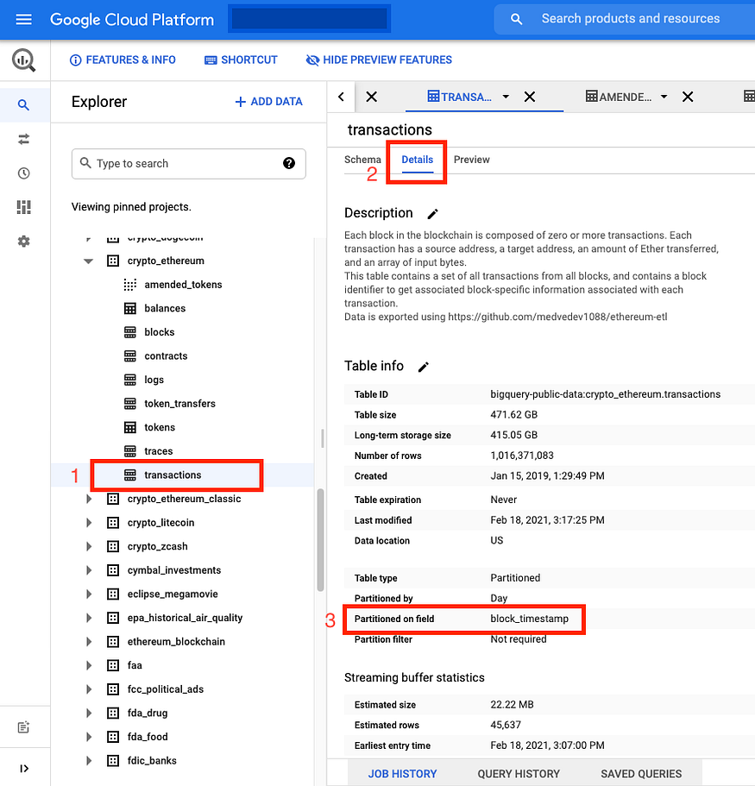

# ****Interactive diagram****

Find an interactive diagram at <https://dbdiagram.io/d/602e721380d742080a3b1265> with more column-level details.

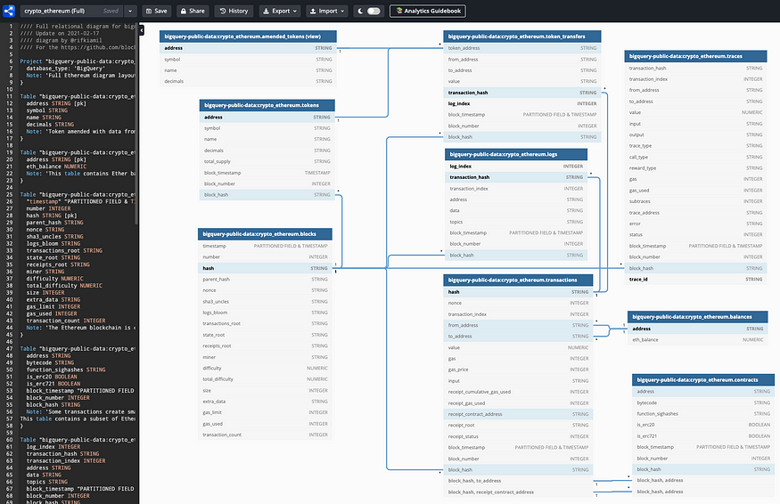

<https://dbdiagram.io/d/602e721380d742080a3b1265>

# Learn SQL and Cryptocurrencies

I have a few posts that will get you learning and using SQL very quick with blockchain data from different cryptocurrencies. Try [“The fastest way to learn SQL with Bitcoin data on a live database from Google”](https://rifkiamil.medium.com/the-fastest-way-to-learn-sql-with-bitcoin-data-on-a-live-database-from-google-part-1-c10480041f0a).